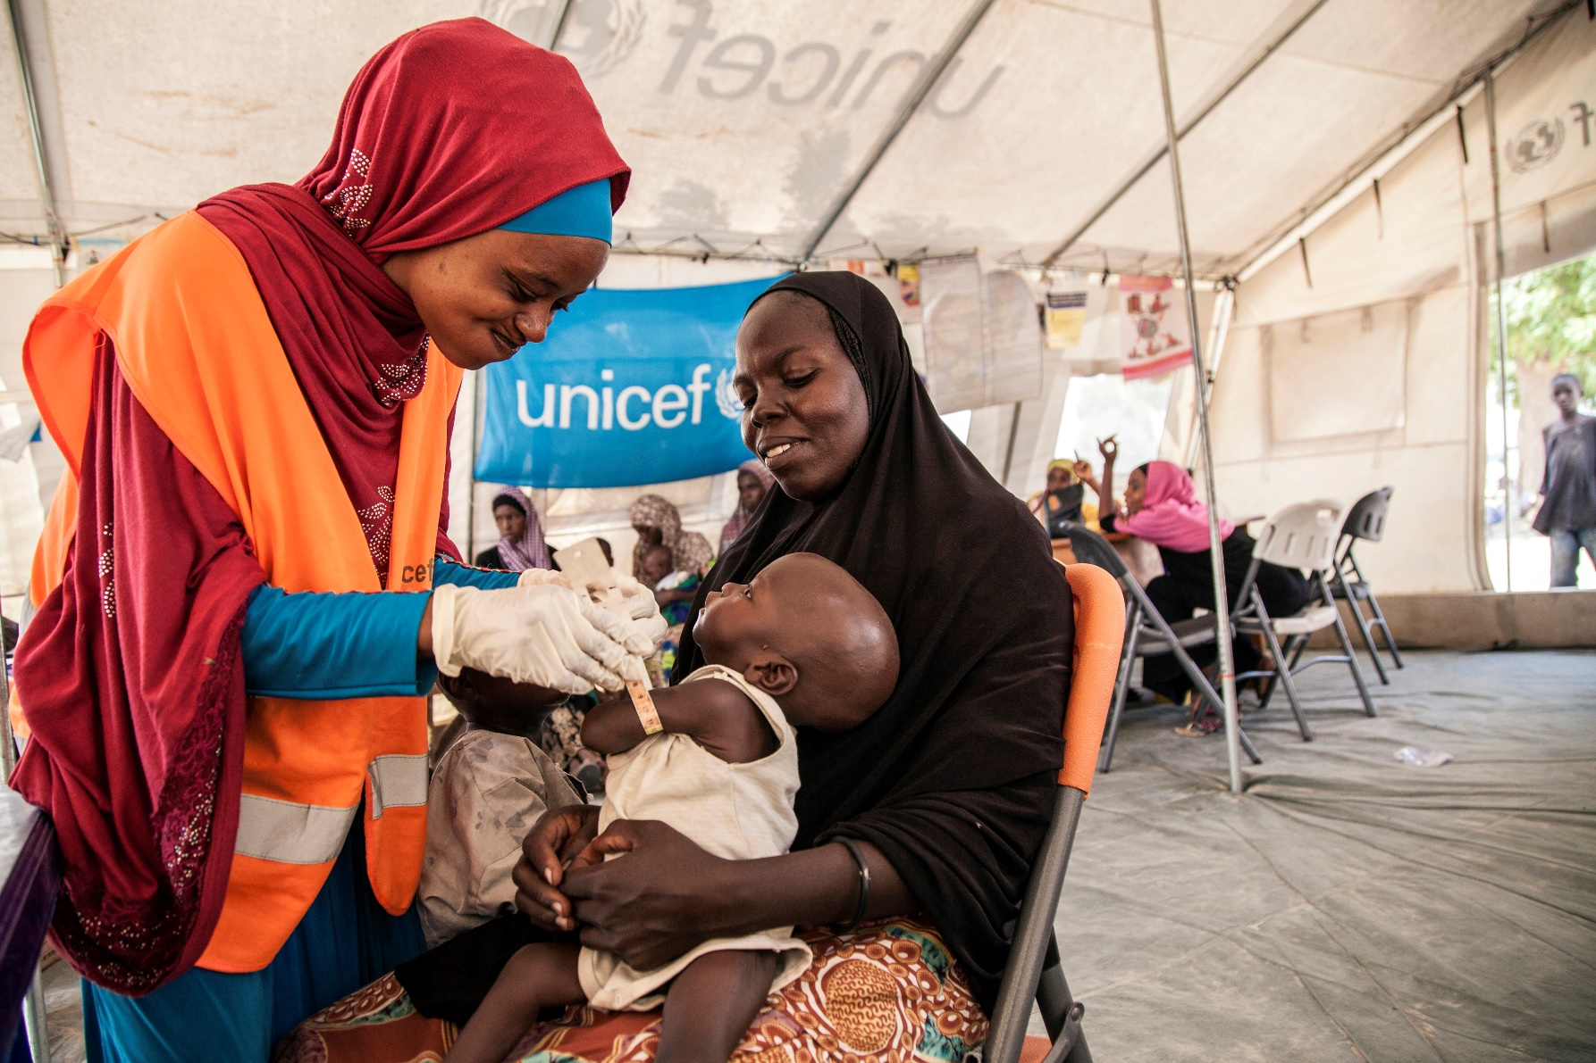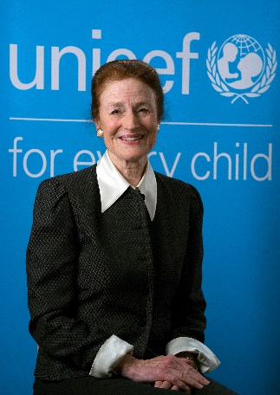

*Become a Champion for Children!*

Senior Fellows Programme

If you would like to explore opportunities, please contact Hiba Frankoul at SeniorFellows[@unicef.org](mailto:afranco@unicef.org)

“*We need to go beyond business as usual – investing in innovation and building broader, bolder partnerships that will help us reach every child.*”

Henrietta H. Fore, UNICEF Executive Director

**We offer challenging assignments, working with highly dedicated and passionate colleagues in a multi-cultural environment. Senior Fellows will benefit from:**

* An assignment that is not business as usual, but an opportunity to contribute meaningfully towards the compelling mandate of the world’s leading child rights organization;
* Exposure to the work of a multi-faceted, multi-cultural UN organization;
* Working directly with, and learning from, talented and motivated UNICEF senior leaders;
* Mentoring by experienced colleagues to facilitate their transition to UNICEF’s work and culture;
* An orientation and learning programme to introduce them to the work of the organization and their office, as well as the culture and values of UNICEF;
* An opportunity to network with like-minded Senior Fellows.

**Our collaboration will involve:**

* One year assignments, renewable to two years.
* Assignments to UNICEF country and regional offices, with a preference to deploy to particularly challenging duty stations.
* UNICEF Senior Fellows will remain employees of the sponsoring partner organization. UNICEF will cover costs associated with official UNICEF travel, office space and equipment.

UNICEF is partnering with the private and public sectors on a structured Senior Fellows Programme. This programme is aligned with the organization’s 2018-2021 Strategic Plan which emphasizes the role of partnerships to accelerate implementation of the 2030 Sustainable Development Goals and to better serve the needs of children.

We are seeking talented senior individuals with expertise in one of our emerging priority areas, and at least 10 years of relevant experience. Senior Fellows will be directly involved in UNICEF programmes and will offer a fresh external perspective which will foster a more innovative approach to delivery of results for children and will help accelerate the work of the organization in support of UNICEF’s strategic priorities.

Join UNICEF as a Senior Fellow to fight for the rights of every child, every day, across the globe